[**Electricity**](http://gcsephysics.com/pe.htm) **Assignment 2 Test**

1.

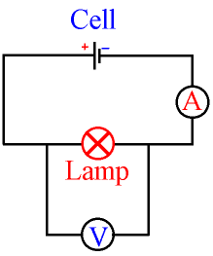

Calculate the power of the light in the circuit above if the ammeter reads 2 A, and the voltmeter reads 6 V.

2.

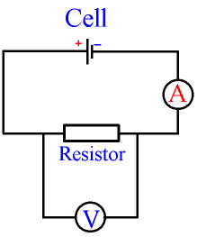

Calculate the resistance of the resistor in the above circuit if the ammeter reads 2 A, and the voltmeter reads 6 V,

3.

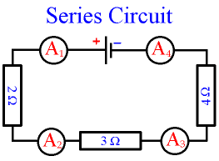

What will be the current readings on

A1

A2

A3

4.

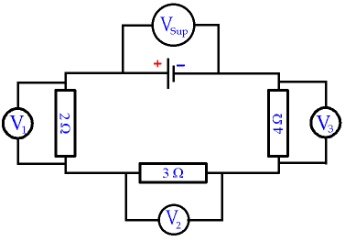

What is the relationship between V1, V2 V3 and Vsup ?

**5.**

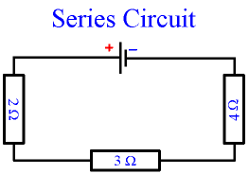

Calculate the total resistance in the above circuit,

6. Calculate the V1, V2, V3 and Vsup readings shown in the circuit below.

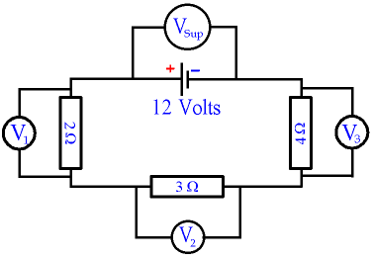

7. Calculate all the ammeter readings shown in the circuit below knowing the supply voltage is 12V.

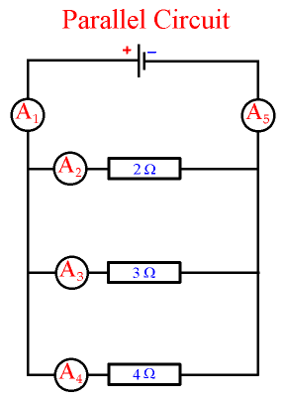

8.

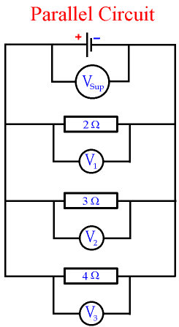

What is the relationship between all the voltmeters in the circuit above.

9.

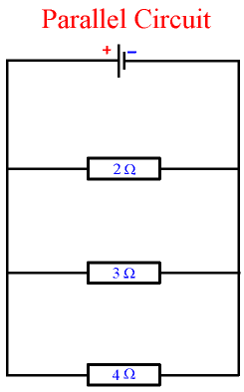

What is the total resistance of the above circuit,

10.

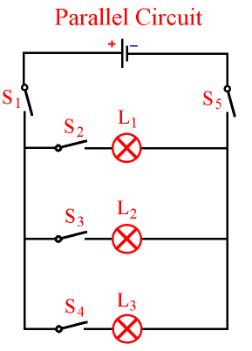

1. Which switches need to be closed for all lights to be on?
2. Which switches need to be closed for light L2 to be on?
3. Define the flowing in terms of **Mains Electricity – Safety**

* Insulation
* Fuses
* Earthing
* DoubleInsulation

1. Define 1kWh (one kilowatt-hour).